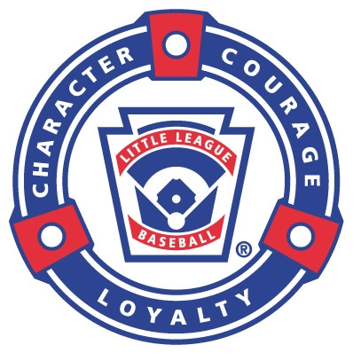
NORTH READING LITTLE LEAGUE 2026 SCHOLARSHIP APPLICATION
The North Reading Little League is proud to offer the following three scholarships for graduating NRHS seniors:
The Phil Dardeno President's Scholarship: This is a $1,000 scholarship given to a NRHS Senior who has also selflessly contributed to the NRLL as a player, coach or volunteer.

The Harold B. Reynolds Memorial Scholarship: This is a $1,000 scholarship given to a NRHS Senior who exemplifies all of the qualities inherent in the Little League motto of “Character, Courage and Loyalty.”

The Matthew Colarusso Memorial Scholarship: This is a $1,000 scholarship given by the Colarusso family to a former NRLL player, and current NRHS Senior, pursuing further education who illustrates the following qualities: Good Sportsmanship, 100% Commitment, and Team Spirit.

Applicant Name: ____________________________________________________________

Address: __________________________________________________________________

Telephone:_________________________Email Address:___________________________

Parent Name / Contact:_______________________________________________________

College you plan to attend:____________________________________________________

Intended Major/Career:_______________________________________________________

HS (Unweighted) GPA:______________ HS (Weighted) GPA:______________

List all Clubs, Charitable, Academic, Sports, Extracurricular Activities and Awards. (You may put this on a separate page or include a resume):
__________________________________________________________________________
__________________________________________________________________________
__________________________________________________________________________
__________________________________________________________________________
__________________________________________________________________________
__________________________________________________________________________
__________________________________________________________________________
-2-
Write a short essay on what “NRLL Baseball Has Meant To Me” or how you believe that you have embodied the Little League motto of “Character, Courage and Loyalty.”
__________________________________________________________________________
__________________________________________________________________________
__________________________________________________________________________
__________________________________________________________________________
__________________________________________________________________________
__________________________________________________________________________
__________________________________________________________________________
__________________________________________________________________________
__________________________________________________________________________
__________________________________________________________________________
__________________________________________________________________________
__________________________________________________________________________
__________________________________________________________________________
__________________________________________________________________________
__________________________________________________________________________
__________________________________________________________________________
Please include any other materials including Letters of Recommendation that you think may enhance your application.

Applicant Signature:__________________________________________________________
Parent/ Guardian Signature:____________________________________________________
Please Return this Application by May 4 to:
NRLL Scholarship Committee
PO Box 619
North Reading, MA 01864
Or Scan and Email to Rich Giannattasio: rgiannattasio@cs.com
Applications. Must be received no later than noon on May 6

